Resume

# Video Decision Tree Model

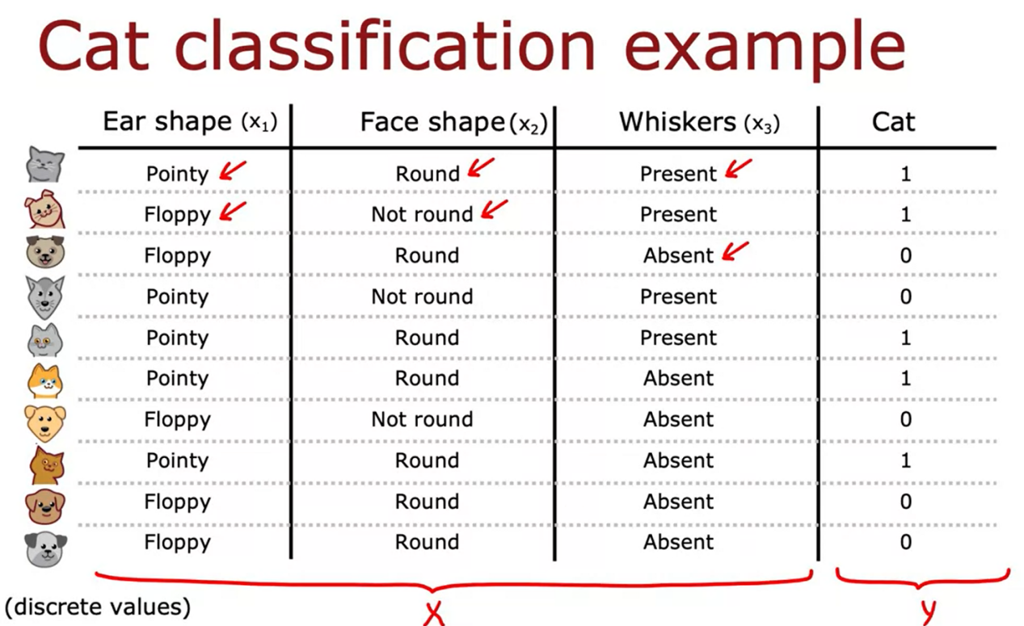

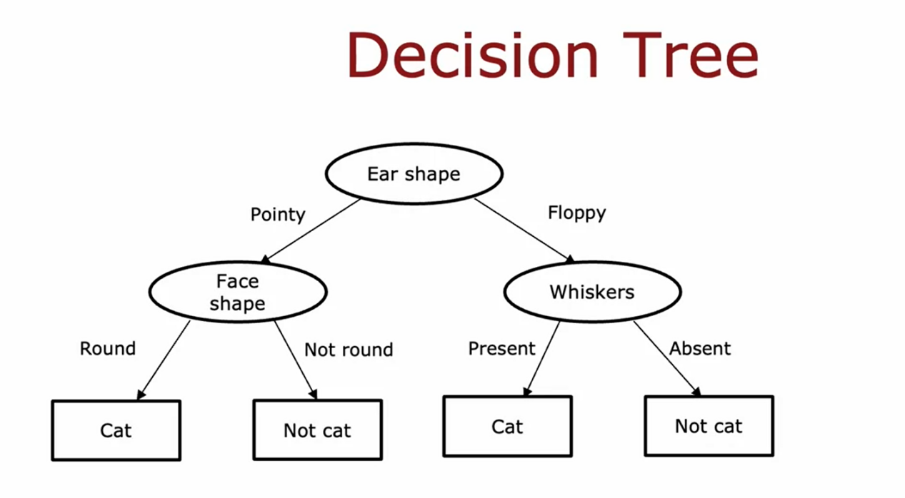

This is a different decision tree for trying to

classify cat versus not cat.

In this tree, to make a classification decision,

you would again start at this topmost root node.

Among these different decision trees,

some will do better and some will do worse on

the training sets or on

the cross-validation and test sets.

The job of the decision tree learning algorithm is,

out of all possible decision trees,

to try to pick one that

hopefully does well on the training set,

and then also ideally generalizes

well to new data such as

your cross-validation and test sets as well.

Seems like there are lots of

different decision trees one

could build for a given application.

How do you get an algorithm to learn

a specific decision tree based on a training set?

# Video Learning Process

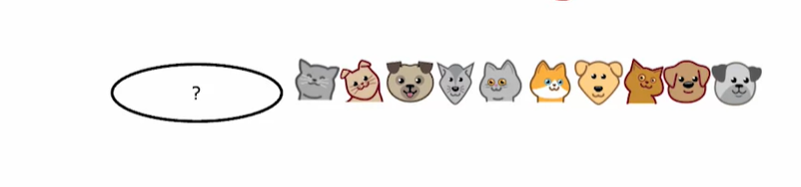

The first step of decision tree learning is,

we have to decide what feature to use at the root node.

That is the first node at

the very top of the decision tree

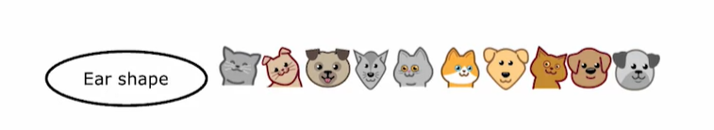

Let's say that we decided to

pick as the feature and the root node,

the ear shape feature.

What that means is we will decide

to look at all of our training examples,

all tangent examples shown here,

I split them according to

the value of the ear shape feature.

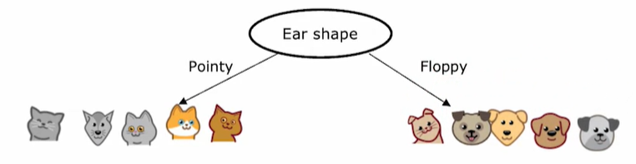

In particular, let's pick out the five examples with

pointy ears and move them over down to the left.

Let's pick the five examples with

floppy ears and move them down to the right.

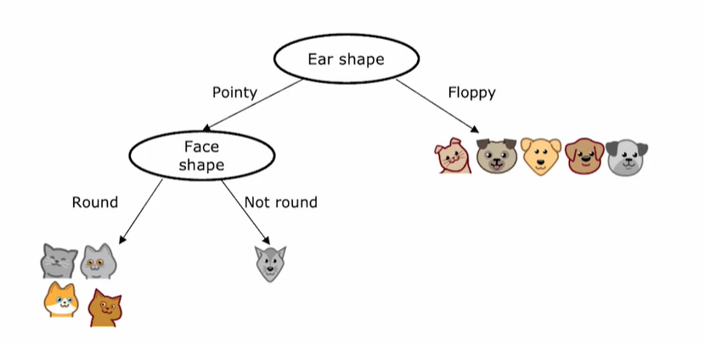

The second step is focusing just on

the left part or sometimes called the left branch

of the decision tree to

decide what nodes to put over there.

In particular, what feature that we want

to split on or what feature do we want to use next.

[inaudible] an algorithm that again,

we'll talk about later this week.

Let's say you decide to use the face shape feature there.

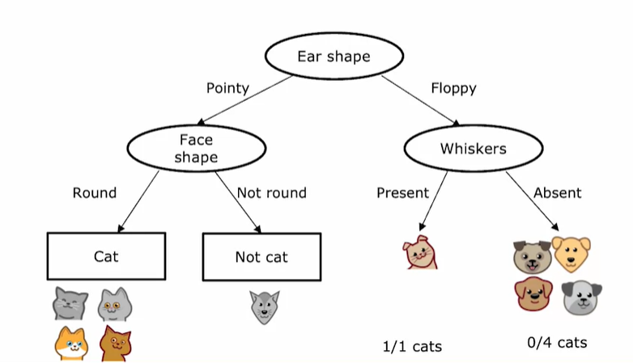

Having done this on the left part to

the left branch of this decision tree,

we now repeat a similar process on

the right part or the right branch of this decision tree.

Focus attention on just these five examples,

which contains one captain for dogs.

We would have to pick some feature over

here to use the split these five examples further,

if we end up choosing the whiskers feature,

we would then split these five examples based on

where the whiskers are present or absent, like so.

You notice that one out of one examples on the left for

cats and zeros out of four are cats.

This is a process of building a decision tree.

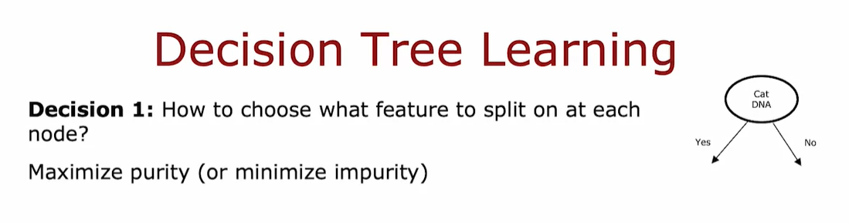

The first key decision was,

how do you choose

what features to use to split on at each node?

At the root node,

as well as on

the left branch and

the right branch of the decision tree,

we had to decide if there were

a few examples at

that node comprising a mix of cats and dogs.

Do you want to split on

the ear-shaped feature or

the facial feature or the whiskers feature?

We'll see in the next video,

that decision trees will choose what feature to split

on in order to try to maximize purity.

By purity, I mean,

you want to get to what subsets,

which are as close as possible to all cats or all dogs.

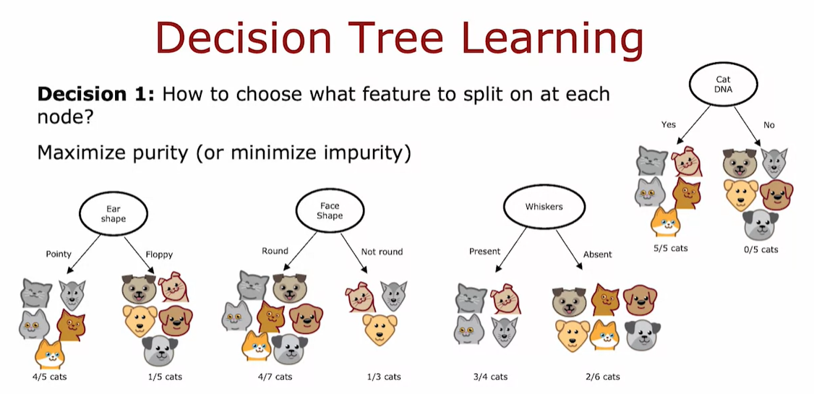

The decision tree learning algorithm has

to choose between ear-shaped,

face shape, and whiskers.

Which of these features results in

the greatest purity of

the labels on the left and right sub branches?

Because it is if you can get to

a highly pure subsets of examples,

then you can either predict

cat or predict not cat and get it mostly right.   
The next video on entropy,

we'll talk about how to estimate

impurity and how to minimize impurity.

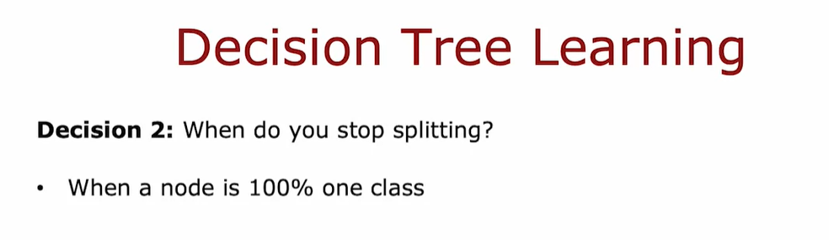

The second key decision you need to make when building

a decision tree is to decide when do you stop splitting.

The criteria that we use just now

was until I know there's either 100 percent,

all cats or a 100 percent of dogs and not cats

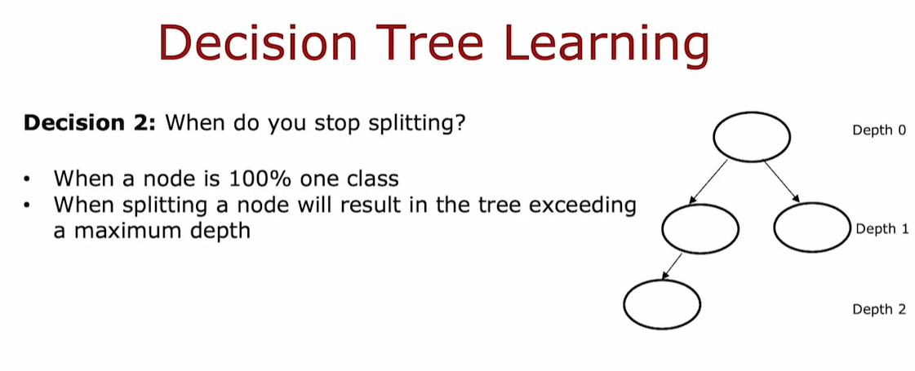

Alternatively, you might also

decide to stop splitting when

splitting and no further results in

the tree exceeding the maximum depth.

Where the maximum depth

that you allow the tree to go to,

is a parameter that you could just say.

In decision tree,

the depth of a node is defined as the number of hops

that it takes to get from the root node that

is denoted the very top to that particular node.

So the root node takes zero hops,

it gets herself and is at Depth 0.

The notes below it are at depth one

and in those below it would be at Depth 2.

If you had decided that

the maximum depth of the decision tree is say two,

then you would decide not to split any nodes below

this level so that the tree never gets to Depth 3.

One reason you might want to

limit the depth of the decision tree

is to make sure for us to tree doesn't

get too big and unwieldy and second,

by keeping the tree small,

it makes it less prone to overfitting

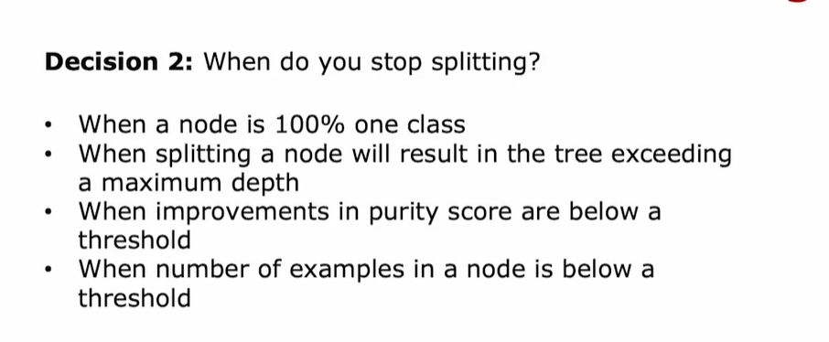

Another criteria you might use to decide to stop

splitting might be if

the improvements in the priority score,

which you see in

a later video of below a certain threshold.

Finally, if the number of

examples that a node is below a certain threshold,

then you might also decide to stop splitting.

# Video Measuring Purity

In this video, we'll look at the way of measuring

the purity of a set of examples.

If the examples are all cats

of a single class then that's very pure,

if it's all not cats that's also very pure,

but if it's somewhere in between how do you

quantify how pure is the set of examples?

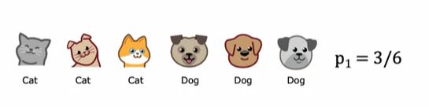

Given a set of six examples like this,

we have three cats and three dogs,

let's define p_1 to be

the fraction of examples that are cats,

that is, the fraction of examples with label one,

that's what the subscript one indicates.

p_1 in this example is equal to 3/6.

We're going to measure the impurity of a set of examples 

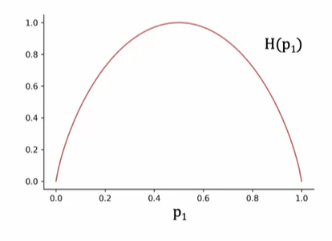

using a function called the entropy which looks like this.

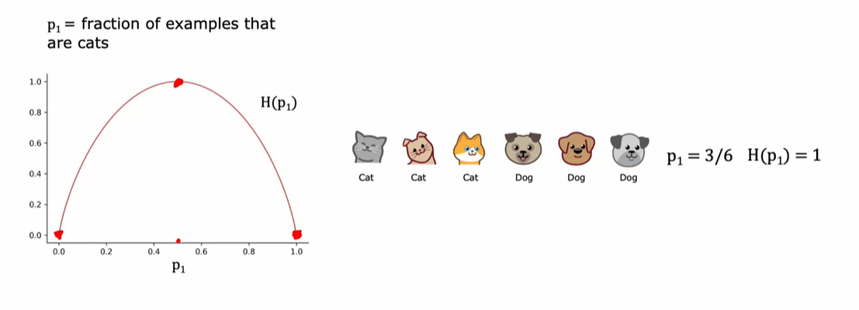

In this example where p_1 is 3/6 or 0.5,

the value of the entropy of p_1 would be equal to one.

You notice that this curve is

highest when your set of examples is 50-50,

so it's most impure as an impurity of one or

with an entropy of one

when your set of examples is 50-50,

whereas in contrast if your set of examples was

either all cats or not cats then the entropy is zero.

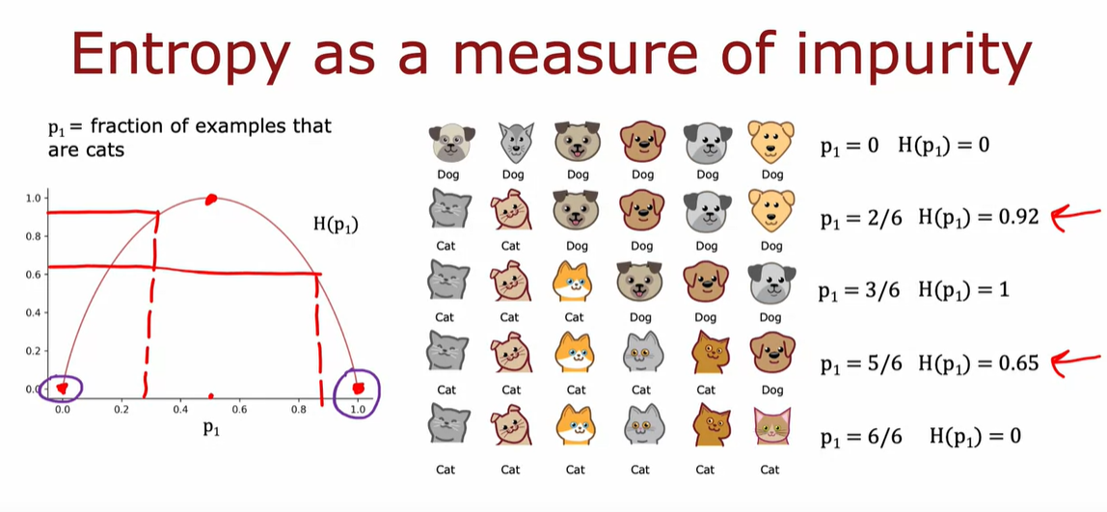

Here's another sample with two cats and four dogs,

so p_1 here is 2/6 which is 1/3,

and if you read off the entropy at

0.33 it turns out to be about 0.92.

This is actually quite impure and in particular

this set is more

impure than this set because it's closer to a 50-50 mix,

which is why the impurity here is

0.92 as opposed to 0.65.

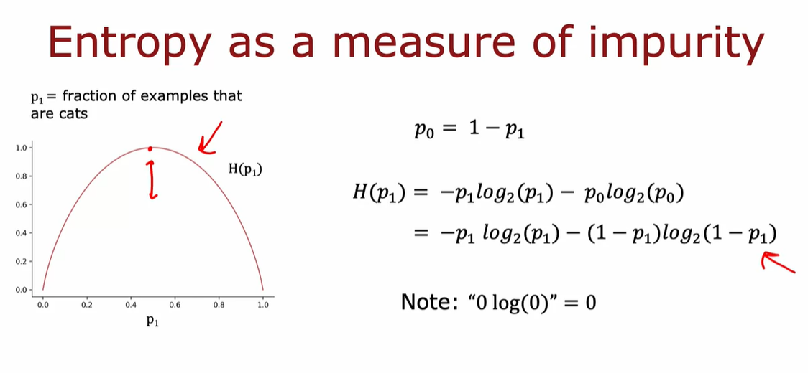

One note on computing this function,

if p_1 or p_0 is equal to 0

then an expression like this will look like 0log(0),

and log(0) is technically undefined,

it's actually negative infinity.

But by convention for the purposes of computing entropy,

we'll take 0log(0) to be equal

to 0 and that will correctly

compute the entropy as zero

or as one to be equal to zero.

To summarize, the entropy function is

a measure of the impurity of a set of data.

It starts from zero, goes up to one,

and then comes back down to zero as a function of

the fraction of positive examples in your sample.

There are other functions that look like this,

they go from zero up to one and then back down.

# Video Choosing a split Information Gain

When building a decision tree,

the way we'll decide

what feature to split on at a node will be

based on what choice of feature reduces entropy the most.

Reduces entropy or reduces impurity, or maximizes purity.

In decision tree learning,

the reduction of entropy is called information gain.

Let's use the example of deciding

what feature to use at the root node

of the decision tree we were building just now

for recognizing cats versus not cats.

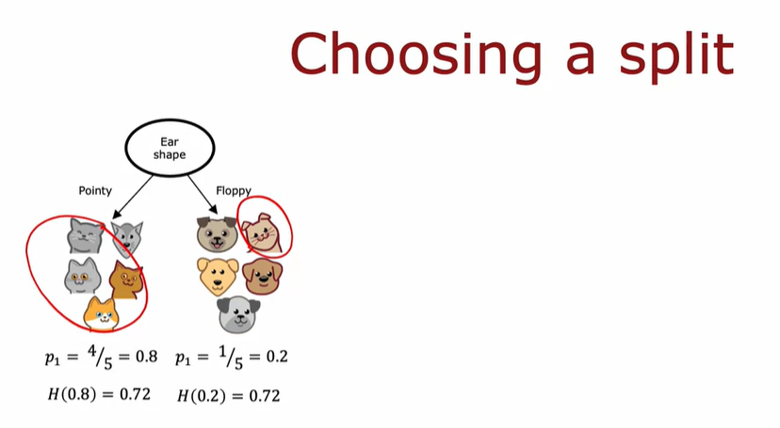

we find that the degree of

impurity on the left is entropy of 0.8,

which is about 0.72,

and on the right,

the entropy of 0.2 turns out also to be 0.72.

This would be the entropy at the left and

right subbranches if we

were to split on the ear shape feature

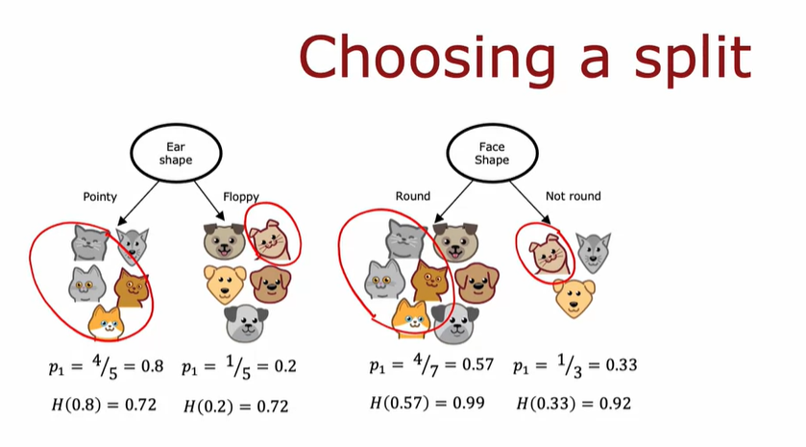

One other option would be to

split on the face shape feature.

The entropy of 4/7 and the entropy

of 1/3 are 0.99 and 0.92.

So the degree of impurity in the left

and right nodes seems much higher,

0.99 and 0.92 compared to 0.72 and 0.72.

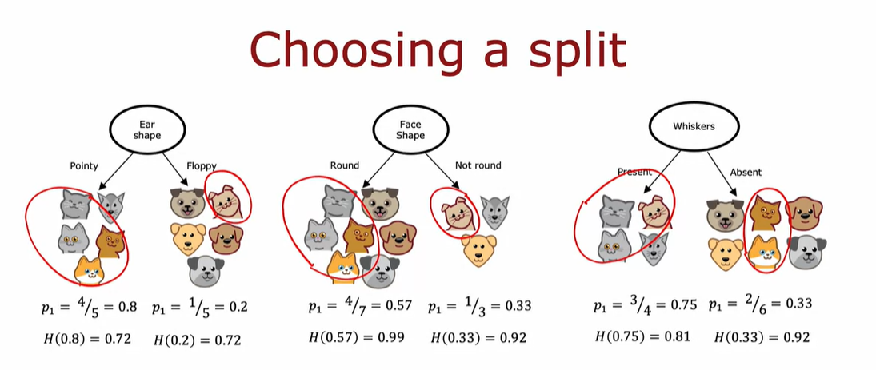

Finally, the third possible choice of

feature to use at the root node would be

the whiskers feature in which case

you split based on whether

whiskers are present or absent.

The key question we need to answer is,

given these three options

of a feature to use at the root node,

which one do we think works best?

It turns out that rather than looking at

these entropy numbers and comparing them,

it would be useful to take

a weighted average of them

and here's what I mean.

If there's a node with a lot of

examples in it with high entropy

that seems worse than if there was a node

with just a few examples in it with high entropy.

Because entropy, as a measure of impurity,

is worse if you have

a very large and impure dataset compared to

just a few examples

and a branch of the tree that is very impure.

So you can just pick

of these three choices, which one does best?

The way we're going to combine

these two numbers is by taking a weighted average.

Because how important it

is to have low entropy in, say,

the left or right sub-branch also depends on

how many examples went into the left or right sub-branch.

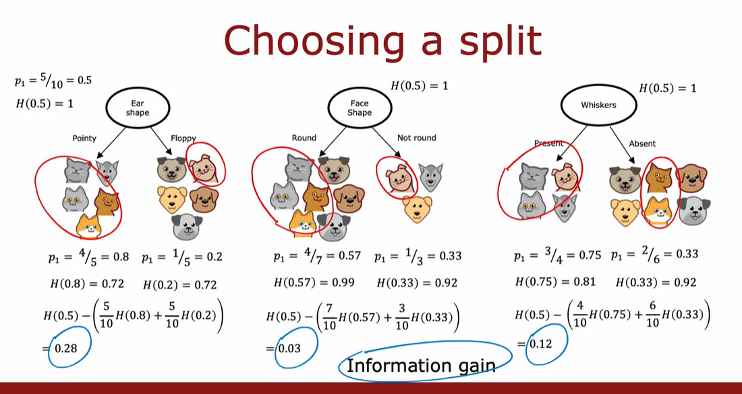

In this other example,

spitting on ear shape results

in the biggest reduction in entropy,

0.28 is bigger than 0.03 or 0.12

and so we would choose to split onto

ear shape feature at the root node.

Let's now write down

the general formula for how to compute information gain.

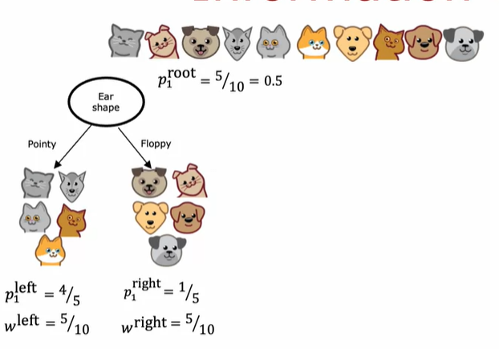

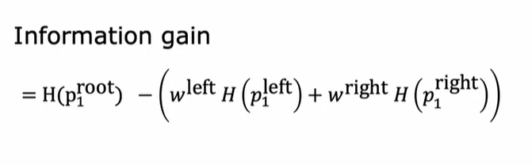

With this definition of entropy,

and you can calculate the information gain associated

with choosing any particular feature

to split on in the node.

Then out of all the possible futures,

you could choose to split on,

you can then pick the one that gives you

the highest information gain.

That will result in, hopefully,

increasing the purity of your subsets of

data that you get on the left and right sub-branches

of your decision tree and that

will result in choosing a feature to split

on that increases the purity of

your subsets of data in

both the left and right

sub-branches of your decision tree.

# Putting IT Together

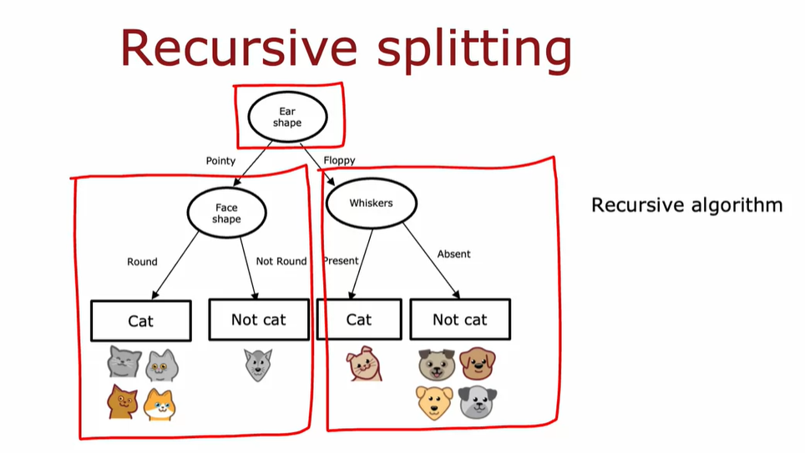

# Video Using one-hot encoding of Categorical Features

From this

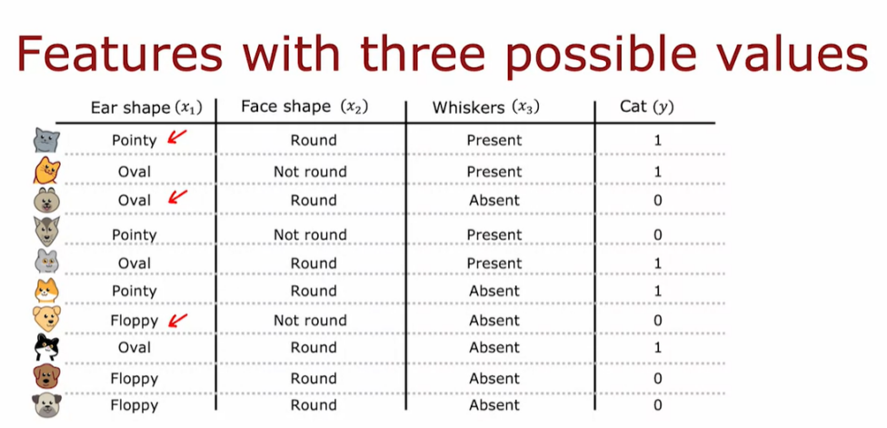

To this

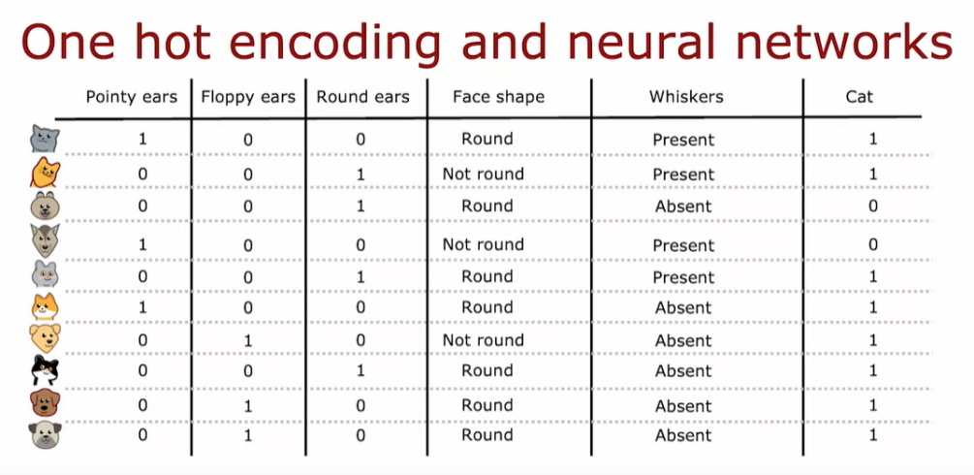

And dan we can convert to categorical to binary numberic

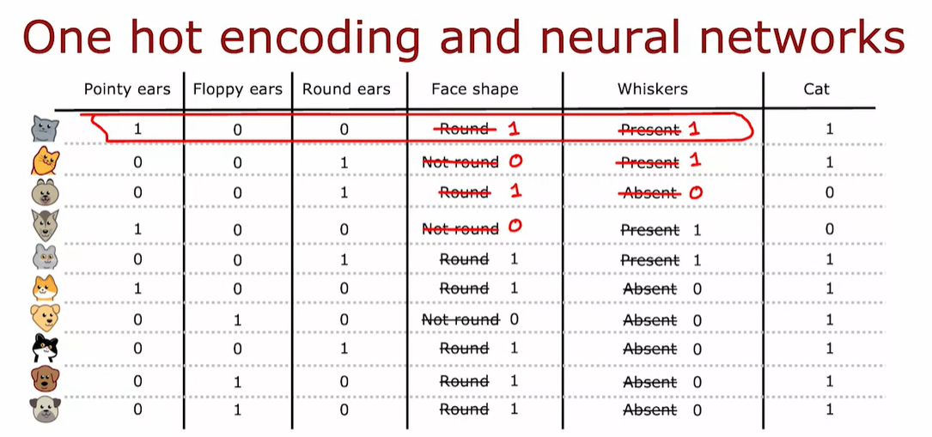

# Continuous Valued Features

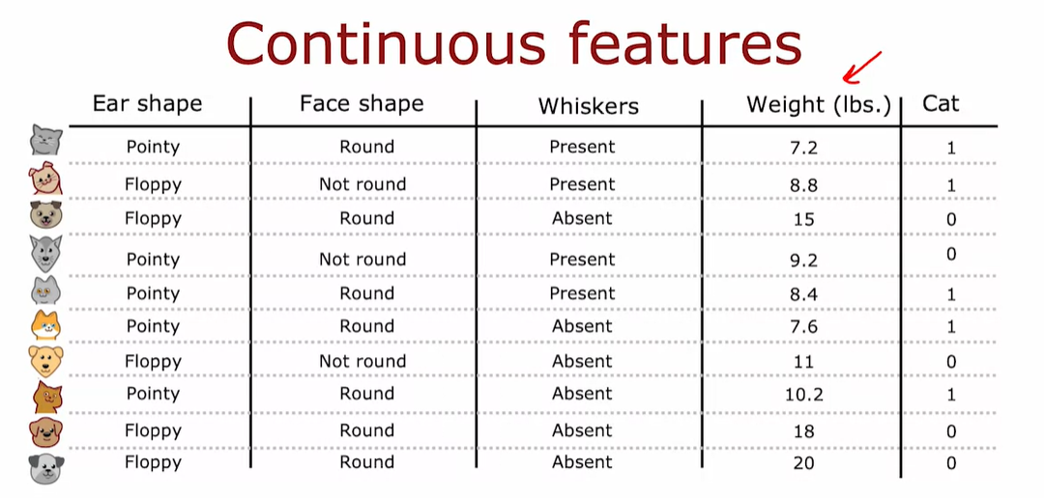

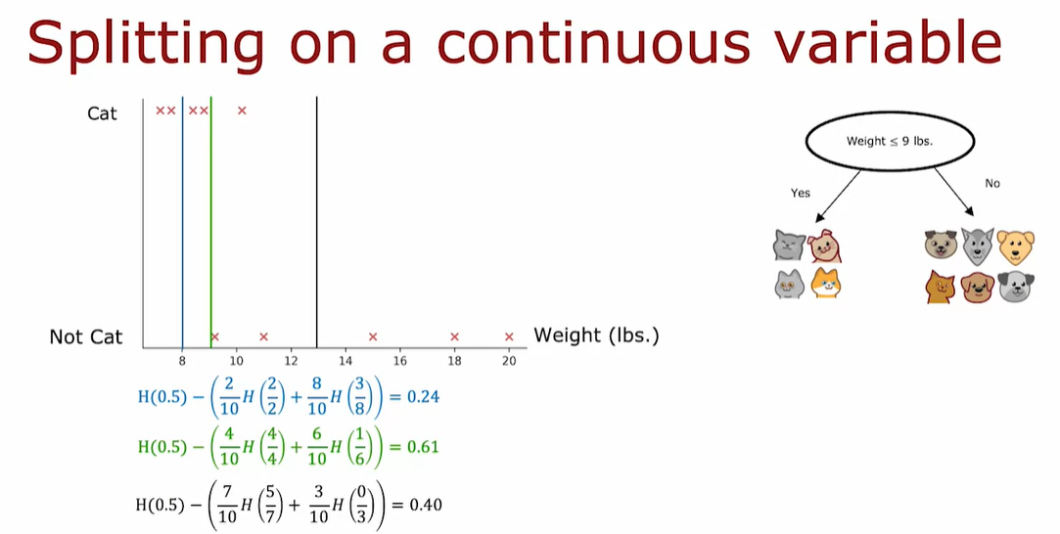

So to summarize to get the decision tree to work

on continuous value features at every note.

When consuming splits, you would just consider different values to split on,

carry out the usual information gain calculation and decide to split on that

continuous value feature if it gives the highest possible information gain.

So that's how you get the decision tree to work with continuous value features.

Try different thresholds, do the usual information gain calculation and

split on the continuous value feature with the selected threshold if it gives you

the best possible information gain out of all possible features to split on.

# VIdeo Regression Trees

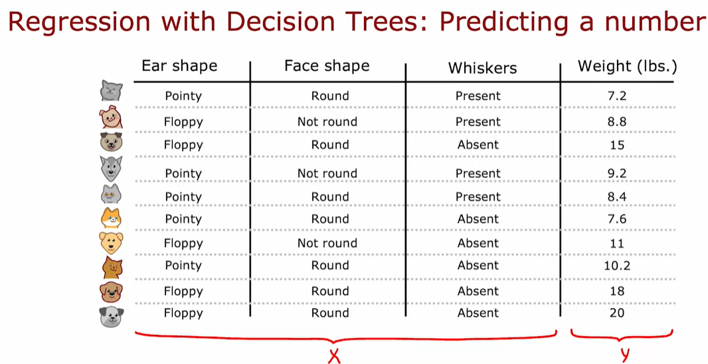

For choose the node we cal calculate variance .

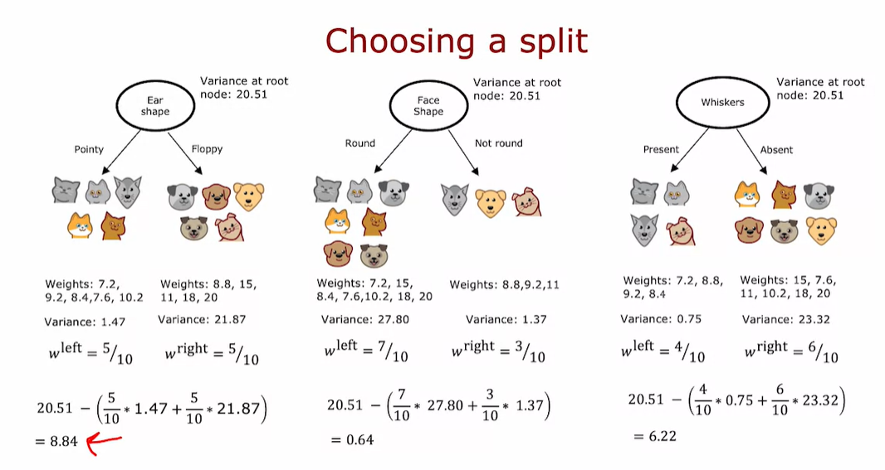

############################### TREE ENSEMBLES #######################

# Using multiple decision trees

One of the weaknesses of using

a single decision tree is that

that decision tree can be highly

sensitive to small changes in the data.

One solution to make the arrow less sensitive or

more robust is to build not one decision tree,

but to build a lot of decision trees,

and we call that a tree ensemble.

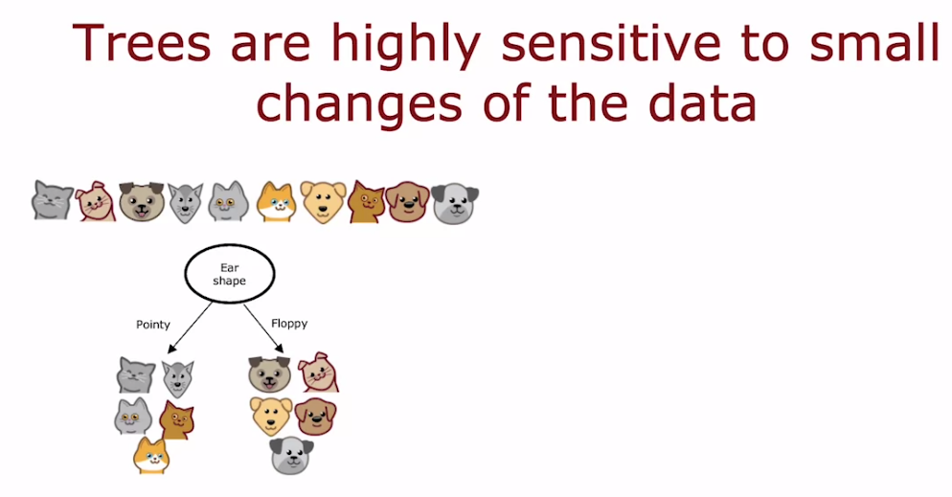

With the example

that we've been using,

the best feature to split on at the root node

turned out to be the ear shape resulting in

these two subsets of the data and then

building further sub trees on

these two subsets of the data.

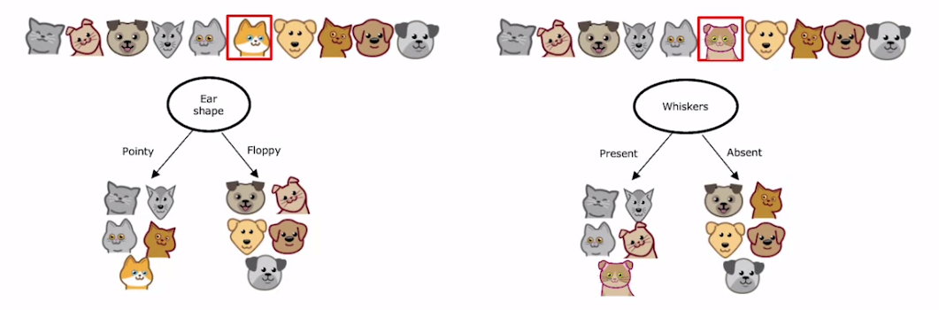

But it turns out that if you were to

take just one of the ten examples and

change it to a different cat

so that instead of having pointy ears,

round face, whiskers absent,

this new cat has floppy ears,

round face, whiskers present,

with just changing a single training example,

the highest information gain feature to split on

becomes the whiskers feature

instead of the ear shape feature.

As a result of that,

the subsets of data you get in

the left and right sub-trees become totally

different and as you continue to

run the decision tree learning algorithm recursively,

you build out totally different sub trees

on the left and right.

The fact that changing just one training example causes

the algorithm to come up with

a different split at the root and

therefore a totally different tree,

that makes this algorithm just not that robust.

That's why when you're using decision trees,

you often get a much better result, that is,

you get more accurate predictions if you train not

just a single decision tree

but a whole bunch of different decision trees.

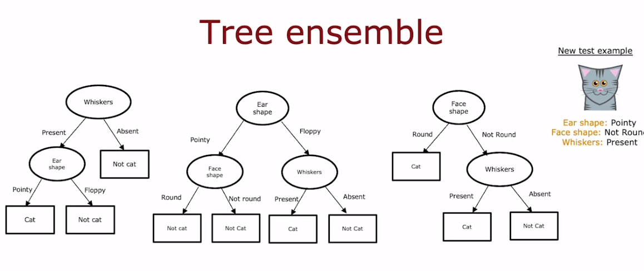

This is what we call a tree ensemble,

which just means a collection of multiple trees

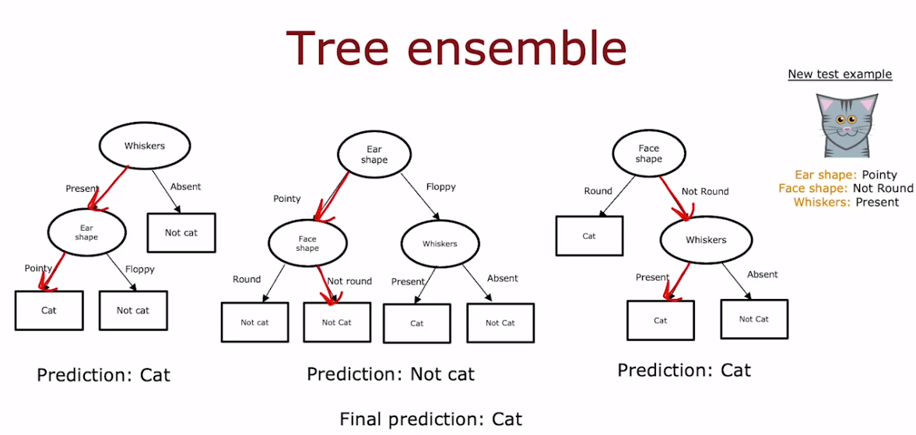

If you had a new test example

that you wanted to classify,

then what you would do is run all three of these trees on

your new example and get them to

vote on whether it's the final prediction.

This test example has pointy ears,

a not round face shape and whiskers are present and so

the first tree would carry out inferences

like this and predict that it is a cat.

The second tree's inference would follow this path

through the tree and therefore predict that is not cat.

The third tree would follow this path and

therefore predict that it is a cat.

These three trees have made

different predictions and so

what we'll do is actually get them to vote.

The majority votes of the predictions

among these three trees is, cat.

The final prediction of this ensemble of trees is

that this is a cat

which happens to be the correct prediction.

The reason we use an ensemble of trees

is by having lots

of decision trees and having them vote,

it makes your overall algorithm less sensitive to what

any single tree may be doing because it

gets only one vote out of three or one vote out of many,

many different votes and it makes

your overall algorithm more robust

# Video Sampling with Replacement

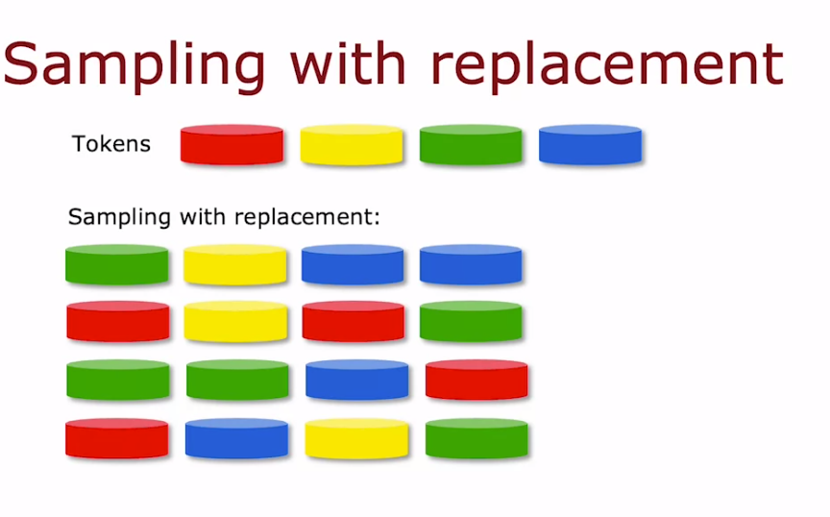

Notice that the with replacement part of this is critical

because if I were

not replacing a token every time I sample,

then if I were to pour four tokens from my bag of four,

I will always just get the same four tokens.

That's why replacing a

token after I pull it out each time,

is important to make sure I don't

just get the same four tokens every single time.

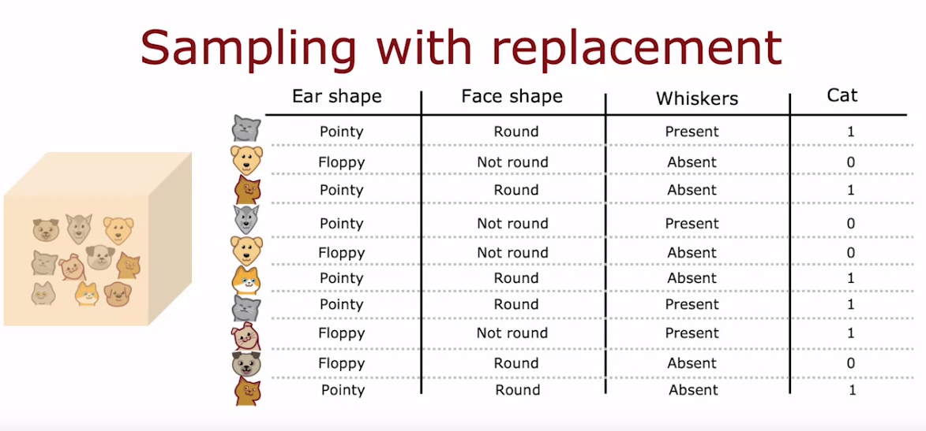

The way that sampling with replacement

applies to building an ensemble of trees is as follows.

We are going to construct

multiple random training sets

that are all slightly different

from our original training set.

In particular, we're going to take

our 10 examples of cats and dogs.

We're going to put the 10 training examples

in a theoretical bag

I'm using this theoretical bag,

we're going to create

a new random training set of

10 examples of the exact same size

as the original data set.

The way we'll do so is we're reaching and

pick out one random training example.

Let's say we get this training example.

Then we put it back into the bag,

and then again randomly pick

out one training example and so you get that.

You pick again and again and again.

Notice now this fifth training example

is identical to the second one that we had out there.

But that's fine. You keep going and keep going,

and we get another repeats the example,

and so on and so forth.

Until eventually you end up with 10 training examples,

some of which are repeats.

You notice also that this training set does not

contain all 10 of

the original training examples, but that's okay.

That is part of the sampling with replacement procedure.

The process of sampling with replacement,

lets you construct a new training set

that's a little bit similar to,

but also pretty different

from your original training set.

It turns out that this would be

the key building block for building an ensemble of trees.

# Random Forest Algorithm

Bagged Decisition Tree

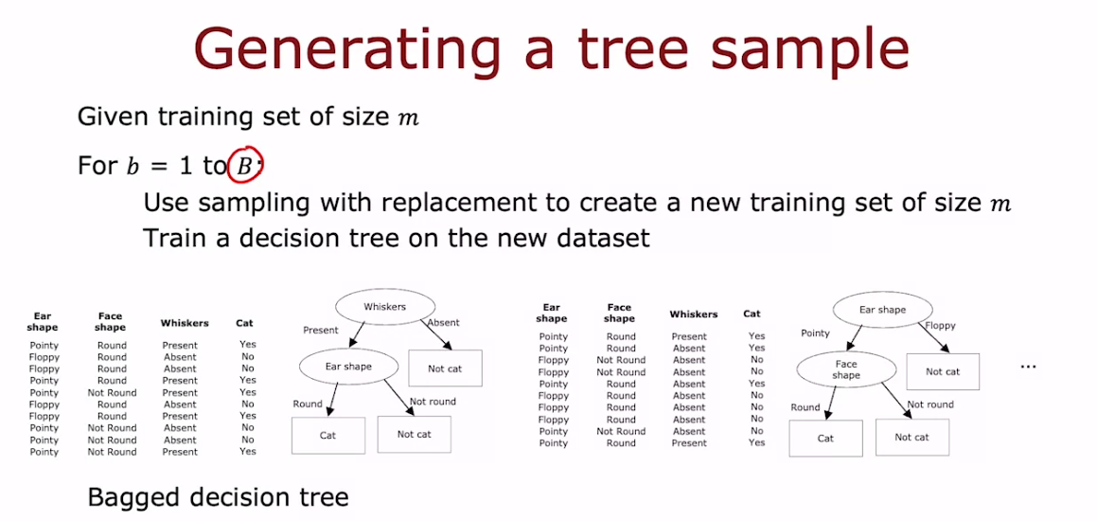

You can use something with replacement to create a new training set of size M.

So if you have 10 training examples, you will put the 10 training examples in

that virtual bag and sample of replacement 10 times to generate a new training set

with also 10 examples, and then you would train a decision tree on this data set.

So here's the data set I've generated using something with replacement.

If you look carefully,

you may notice that some of the training examples are repeated and that's okay.

And if you train the decision on this data said you end up with this decision tree.

And having done this once, we would then go and repeat this a second time.

Use something with replacement to generate another training set of M or

10 training examples.

This again looks a bit like the original training set but

it's also a little bit different.

You then train the decision tree on this new data set and

you end up with a somewhat different decision tree.

And so on.

And you may do this a total of capital B times.

Typical choice of capital B the number of such trees you built might be

around a 100 people recommend any value from Say 64, 228.

And having built an ensemble of say 100 different trees,

you would then when you're trying to make a prediction,

get these trees all votes on the correct final prediction.

It turns out that setting capital B to be larger, never hurts performance,

but beyond a certain point, you end up with diminishing returns and

it doesn't actually get that much better when B is much larger than say 100 or so.

And that's why I never use say 1000 trees that just slows down the computation

significantly without meaningfully increasing the performance of

the overall algorithm.

Just to give this particular album a name.

This specific instance creation of tree ensemble is sometimes also called a bagged

decision tree.

And that refers to putting your training examples in that virtual bag.

And that's why also we use the let us lower case B an uppercase B

here because that stands for bag.

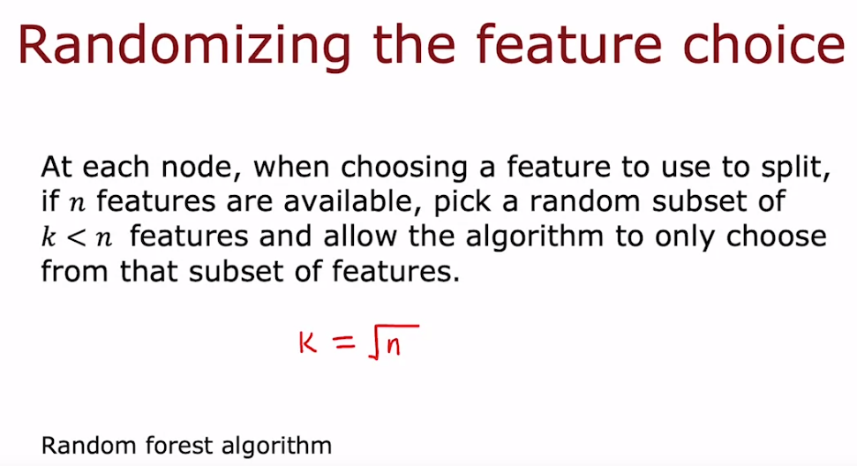

There's one modification to this album that will actually make it work even much

better and that changes this algorithm the back decision tree into the random forest

algorithm.

The key idea is that even with this sampling with replacement procedure

sometimes you end up with always using the same split at the root node and

very similar splits near the root note.

That didn't happen in this particular example where a small change the trainings

that resulted in a different split at the root note.

But for other training sets it's not uncommon that for many or

even all capital B training sets, you end up with the same choice of

feature at the root node and at a few of the notes near the root note.

So there's one modification to the algorithm to further try to randomize

the feature choice at each note that can cause the set of trees and

you learn to become more different from each other.

So when you vote them, you end up with an even more accurate prediction.

The way this is typically done is at every note when choosing

a feature to use to slit if end features are available.

So in our example we had three features available rather than picking from all end

features, we will instead pick a random subset of K less than N features.

And allow the algorithm to choose only from that subset of K features.

So in other words, you would pick K features as the allowed features and

then out of those K features choose the one with the highest

information gain as the choice of feature to use the split.

When N is large, say n is Dozens or 10's or even hundreds.

A typical choice for the value of K would be to choose it to be square root of N,

In our example we have only three features and this technique tends to

be used more for larger problems with a larger number of features.

And will just further change the algorithm you end up with the random Forest

algorithm which will work typically much better and

becomes much more robust than just a single decision tree.

One way to think about why this is more robust to than a single decision tree is

the something with replacement procedure causes the algorithm to explore a lot of

small changes to the data already and it's training different decision trees and

is averaging over all of those changes to the data that the something

with replacement procedure causes.

And so this means that any little change further to the training set makes it less

likely to have a huge impact on the overall output of the overall random

forest algorithm.

Because it's already explored and

it's averaging over a lot of small changes to the training set

# Video XGBoost

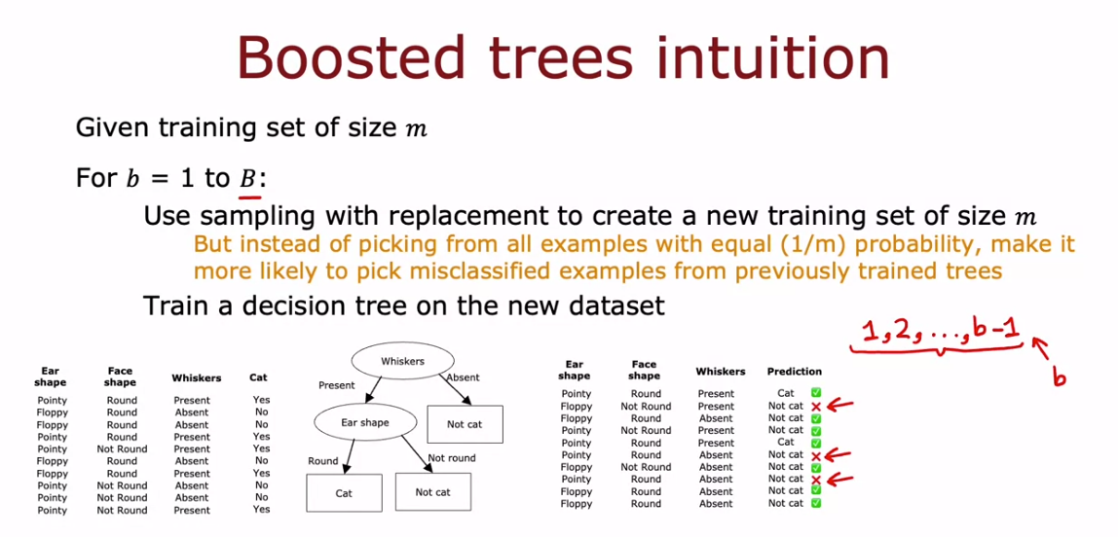

Still not understand , check more in youtube .

